Using the Simulator
Overview
Cross Examination is a genetics mapping simulator with three tabs: MPP, Biparental QTL, and GWAS. Each tab simulates a different study design for mapping the genetic basis of a quantitative trait. The controls on the left set the experimental parameters; the plots on the right show the output after you click Simulate.
If you turn Teaching Mode ON before running, the true QTL positions and runs become fixed, so every student in the class sees the same result.

The MPP Tab — Controls
The MPP tab simulates a multiparent population (MPP) mapped with bulk segregant analysis (BSA). Cases are the top N individuals by phenotype; controls are a random N drawn from the non-extreme individuals. The CMH test combines signal across replicates.
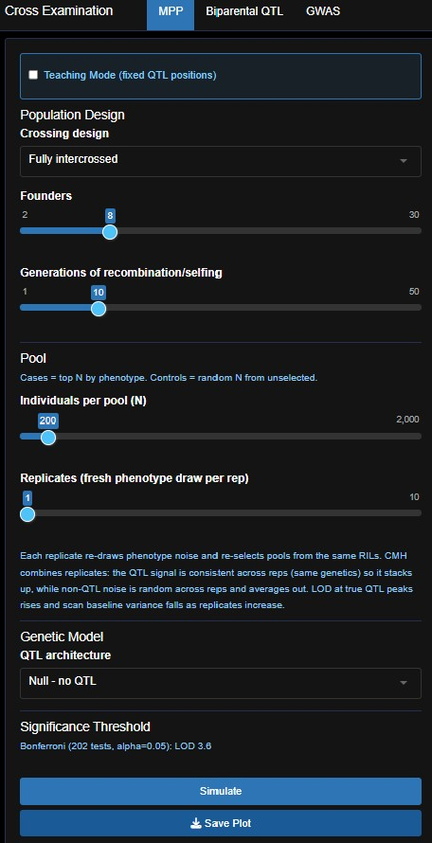
Number of Replicates: slider to change the number of independent replicates drawn
Number of inbred Founders: slider to change values
Save Plot Button to save the simulated design
Simulate Button to simulate the design
Genetic Model: Null – no QTL, 1 QTL, 2 QTLs, 3 QTLs, and Polygenic in the dropdown menu – same for all tabs
Individuals per pool (N): the number of individuals sequenced in each pool of cases/controls
Generations of recombination/selfing: slider to change values
Crossing Design: Fully Intercrossed or Hub-and-Spoke in the dropdown menu
Teaching Mode: check box for on position
Design Tabs: MPP, Biparental QTL, & GWAS

The MPP Tab — Reading the Output
After you click Simulate, three panels appear on the right. The top two show population structure; the bottom two show the mapping results.
Founder Haplotypes: Each row is one founder line, fully inbred. Every position is fixed in that founder.
RIL Haplotype Mosaic: Each row is one RIL/individual (50 max plotted). The patchwork of founder colors shows where recombination changed ancestry.

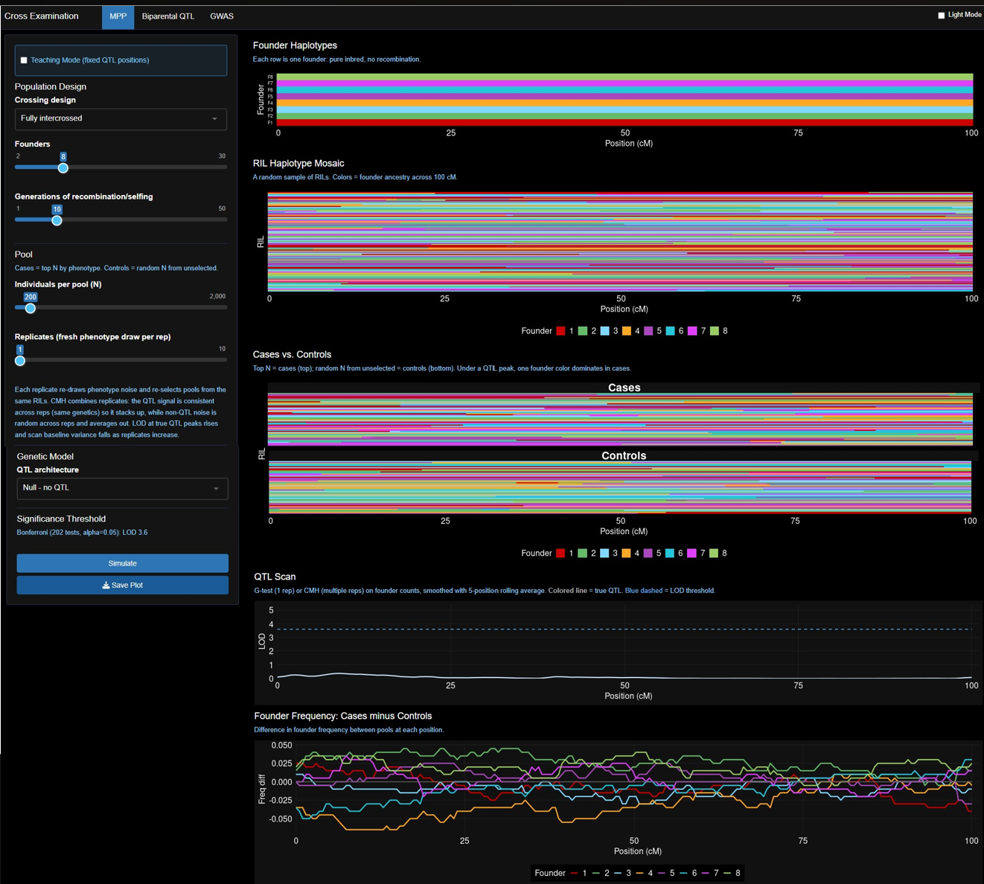
Cases vs. Controls: Haplotype mosaics for the selected extreme pools. Under a QTL, one founder color is overrepresented in cases.

QTL Scan: LOD score at every genomic position using a G-test (or CMH test if multiple replicates). The colored vertical line marks the true QTL. The dashed line is the Bonferroni significance threshold.

Founder Frequency (Cases – Controls): For each founder at each position, the difference in haplotype frequency between cases and controls is plotted. Under a QTL, the founder carrying the effect allele shows a large positive shift.

The Biparental QTL Tab — Interface and Output
Two inbred parents are crossed to make F₁, then intercrossed to make F₂ offspring. Each F₂ genome is a mosaic of the two parental haplotypes. A regression test at each position detects linkage between genotype and phenotype.
Parents panel: P1 (red) and P2 (blue) are fully inbred, and every locus is fixed.

F₂ Individuals: the sample size for the QTL or the number of F₂ Individuals.

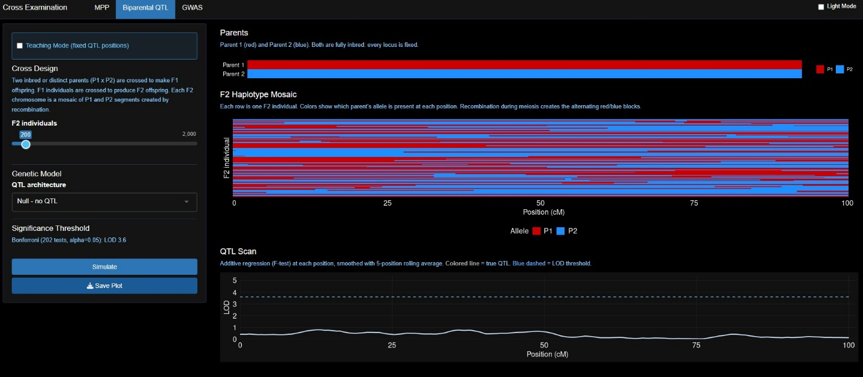
F₂ haplotype mosaic: Each row is one F₂ individual. Alternating red/blue blocks show where recombination changed parental haplotypes.
QTL Scan: LOD score at each genomic position (smoothed). The colored vertical line marks the true QTL. The blue dashed line is the Bonferroni significance threshold.

The GWAS Tab — Interface and Output
Simulates a genome-wide association study (GWAS) in an outbred population. Individual genotypes are tested for differences in allele frequencies between cases and controls at each of 1,000 SNPs.
Light Mode: Makes the background white instead of black when enabled.
LD block size: Controlled by the slider. Small blocks are more diverse, outbred populations, while large blocks are bottlenecked or recently hybridized species.
Individuals: the sample size for the GWAS or number per cases/controls.

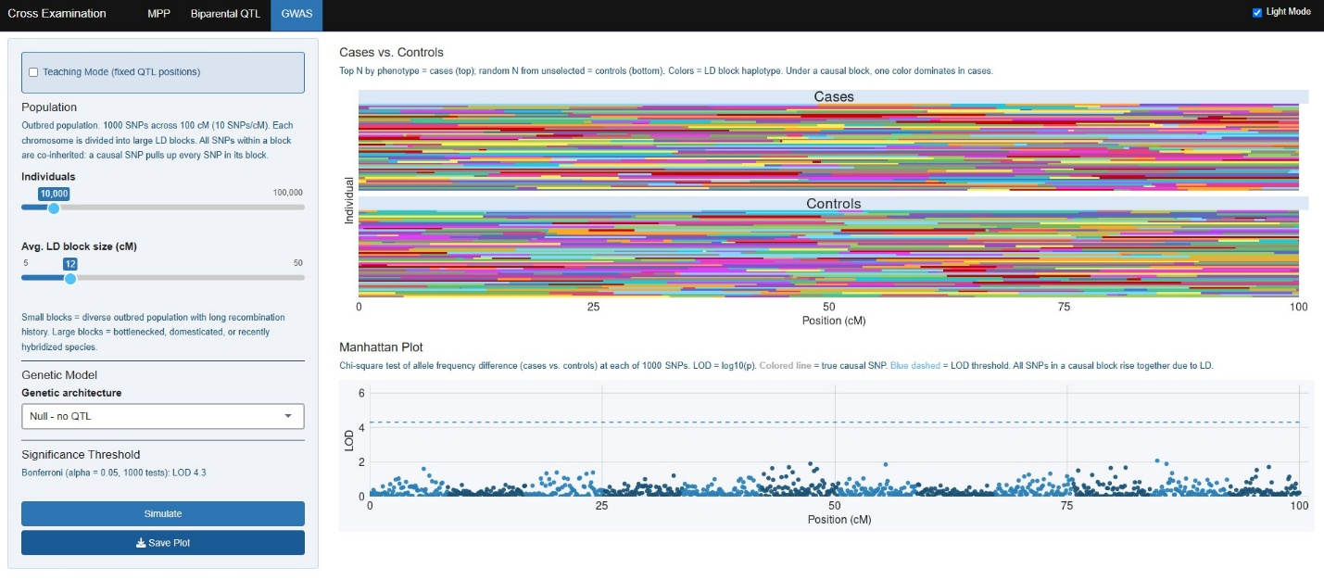
Manhattan Plot: LOD = log₁₀(p) from a chi-square test at each SNP. All SNPs in a causal LD block rise together. The colored vertical line marks the true causal SNP; the blue dashed line is the Bonferroni threshold.
Cases vs. Controls: Each row is one individual. Colors show LD block haplotypes. Under a causal block, one color dominates in cases relative to controls.

